**KASHISH SHARMA**

**31011123056**

**PROJECT DESIGN**

**NGO MANAGEMENT SYSTEM**

**ER DIAGRAM**

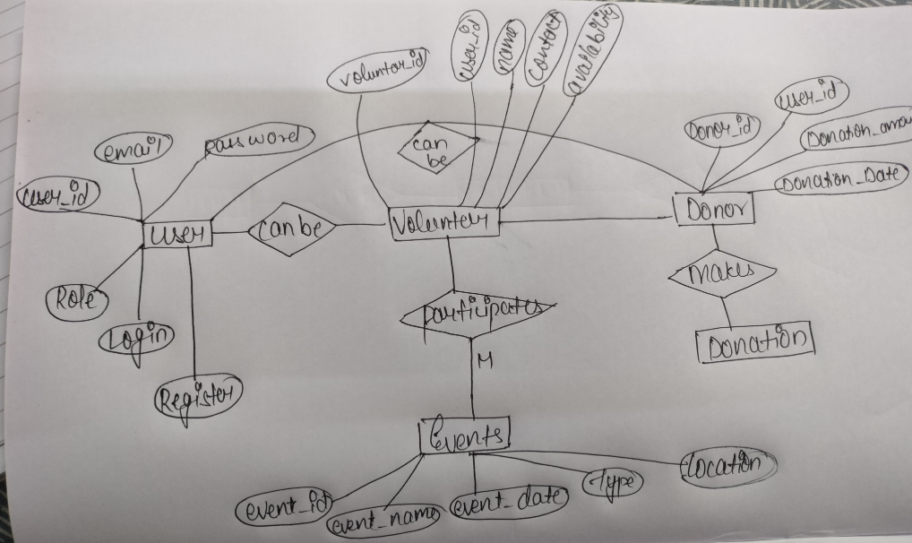

**LOGIN PAGE**

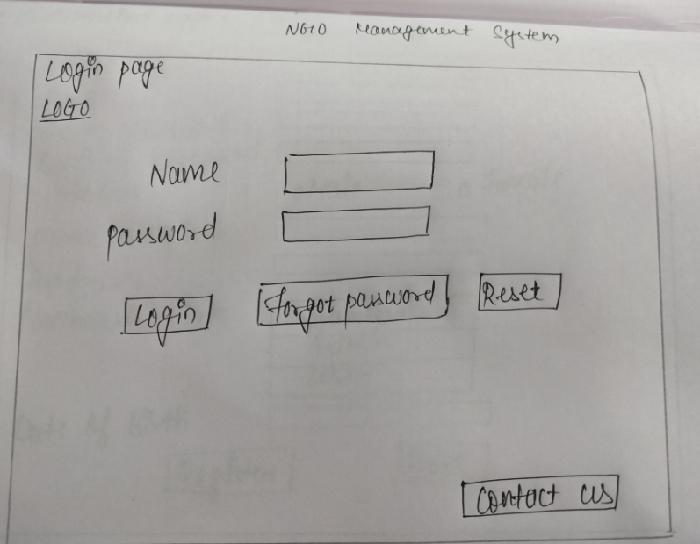

**REGISTRATION PAGE**

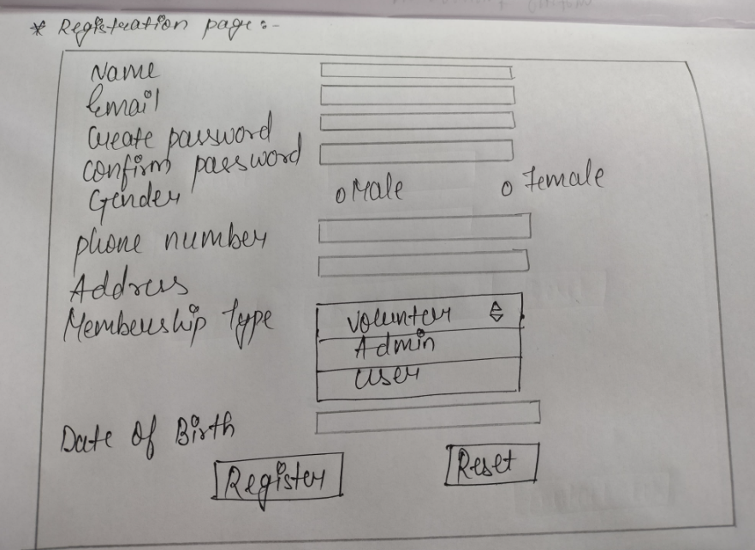

**DASHBOARD**

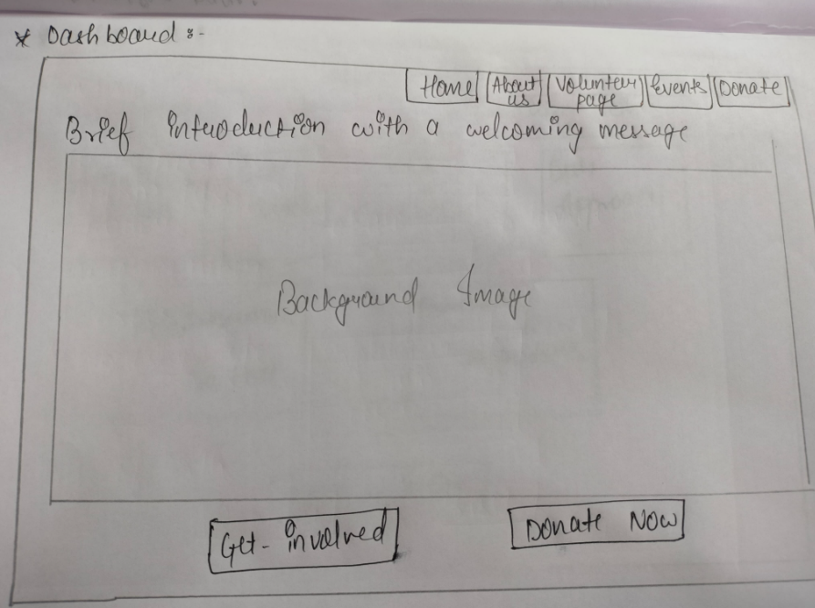

**ABOUT US**

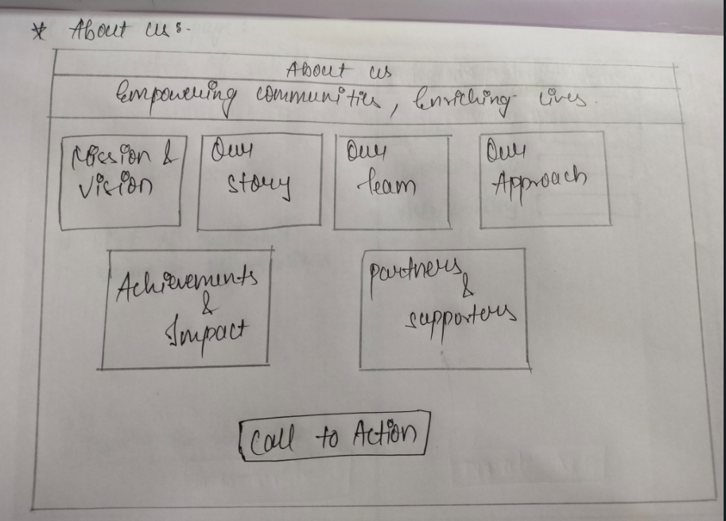

**VOLUNTEER PAGE**

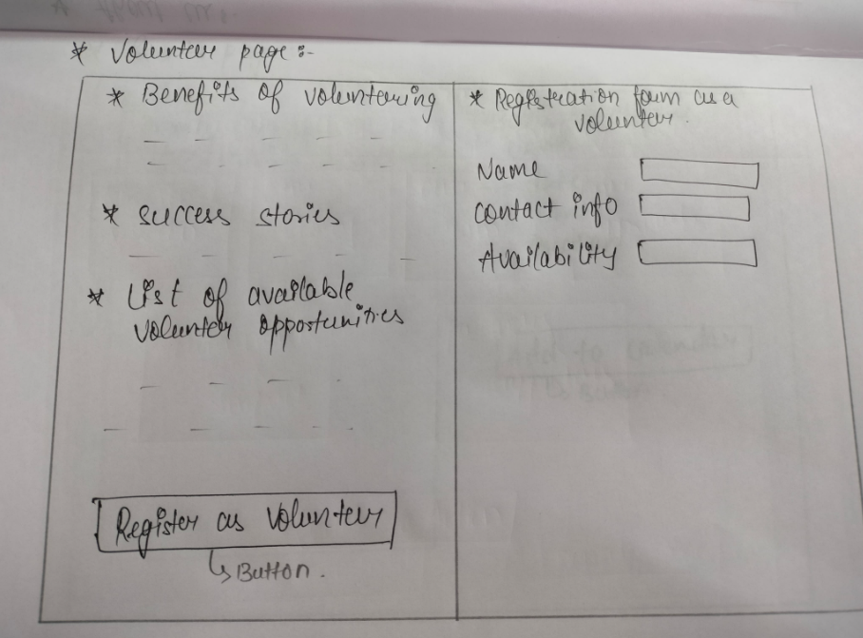

**EVENTS PAGE**

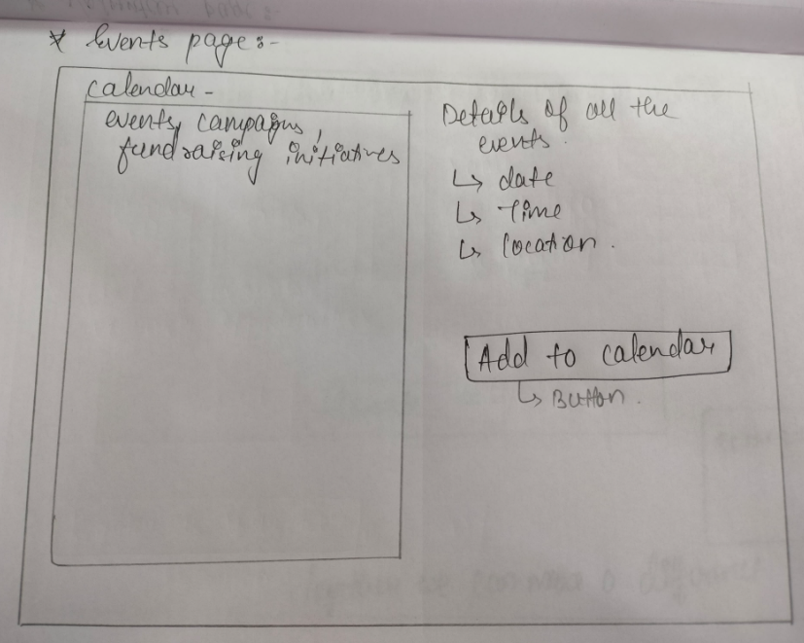

**DONATION PAGE**

